CHALLENGE 01:
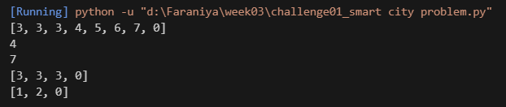
CHALLENGE 02:
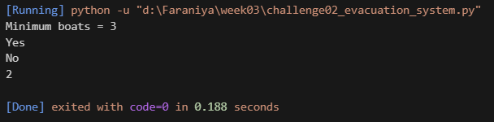
CHALLENGE 03:
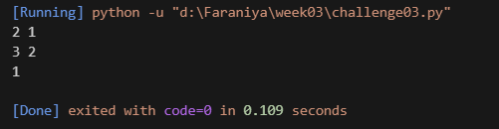
CHALLENGE 04:
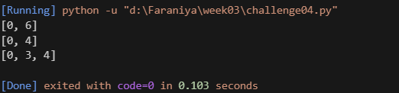
CHALLENGE 05:
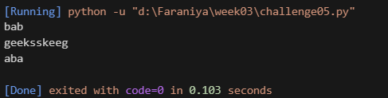
CHALLENGE 06:
